**Evacuation Go-Kit**

Assemble your go-kit before a wildfire or other disaster occurs and keep it easily accessible so you can take it with you when you must evacuate. Plan to be away from your home for an extended period of time. **Each person in your household should have a readily accessible go-kit and keep a spare for visitors.** Backpacks work great for storing these items and are easy to carry when you leave. Keep it light enough to be able to carry on foot, if needed.

What is in a Go-Kit?

Everything you need to get through 2 or 3 days when you cannot get into your home, plus some things you might need to get your life back on track in case you home is damaged or destroyed.

You can start with a simple kit (from Amazon.com) and add things to it. Or build your own. You will want to add a copy of your important financial documents, passports, account numbers and so forth, a few days of any medications you take, copy of your family’s emergency communications plan. Keep a photo of each family member and pet, to make it easier to find each other. Keep a physical copy in your go-kit and an electronic copy on a USB drive or “in the cloud”.

Go-Kit Checklist

* A sturdy pair of shoes (preferably boots) and a spare flashlight near your bed and handy in case of a sudden evacuation at night
* Long sleeve shirt, long pants, cotton (all should be cotton or wool, bright colors are best)
* Leather work gloves
* Full coverage goggles
* Respirator (N95, available at most hardware stores)
* Map marked with at least two evacuation routes (if possible)
* Prescription medication (ask your doctor for a multi-day emergency supply, rotate annually)
* Water bottle
* A small supply of energy food
* Spare battery and charger for cell phone
* Extra eyeglasses or contact lenses
* An extra set of car keys, credit cards, cash or traveler’s checks
* First aid kit (compact)
* Headlamp
* Flashlight (handheld)

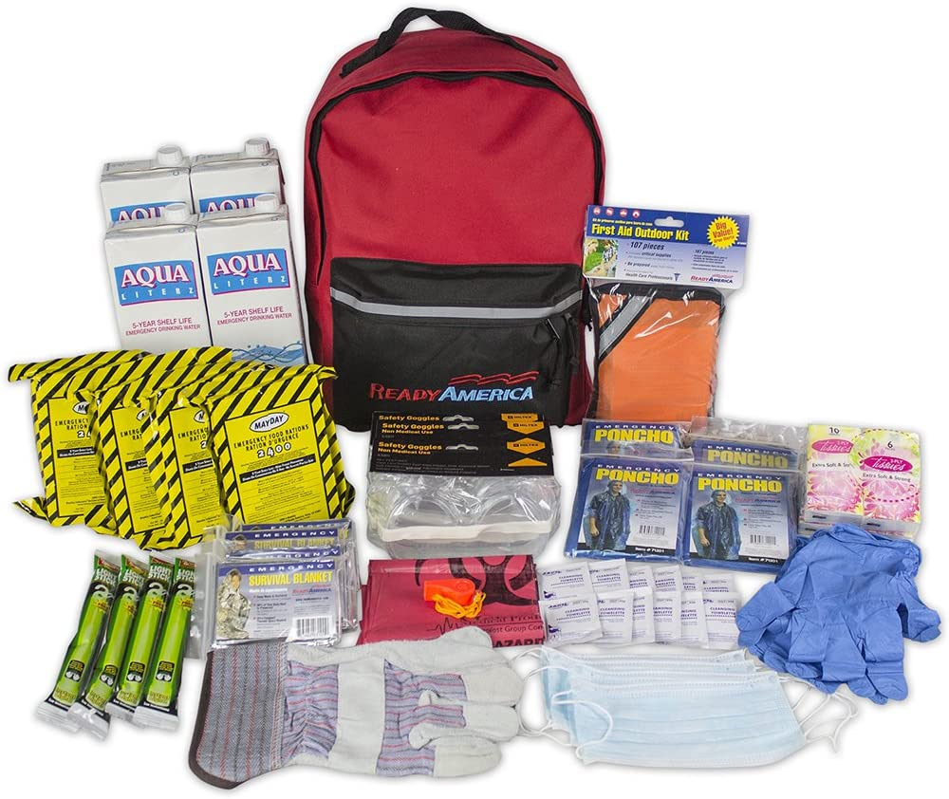

* Battery-powered radio
* Spare batteries for flashlights, headlamp, and radio
* Sanitation supplies (toilet paper, feminine hygiene, baby wipes/diapers, etc.)
* Copies of important documents (birth certificates, passports, etc.)
* Pet supplies: carriers for each pet, leashes, food, and water

### **Things to Take if Time Allows**

* Easily carried valuables
* Three-day supply of non-perishable food and three gallons of water per person
* Family photos and other small, irreplaceable items
* Personal computer information on hard drives and disks (off-site or cloud/online backup is best)
* Spare chargers for cell phones, laptops, etc.

## Dress For Survival Checklist

When preparing to evacuate, dress yourself and your family in clothes that will shield you from heat, embers, and flames. Natural fabrics, such as heavy denim or pure wool are better than synthetics, no matter how hot it is. Keep these items near your go-kit during fire season, and keep a set near your bed before laying down during a [Red Flag Warning.](https://www.firesafesanmateo.org/news/entry/red) Put these clothes on at the first sign of trouble. If you can smell or see smoke, it’s time to prepare.

* Sturdy leather boots with Vibram-lug soles
* Full-coverage goggles
* Leather work gloves
* Long pants (wool or cotton) with a sturdy belt
* Long-sleeved shirt that covers neck (tuck into pants)
* Floppy cotton hat
* Handkerchief or bandana to cover face
* Wool socks

[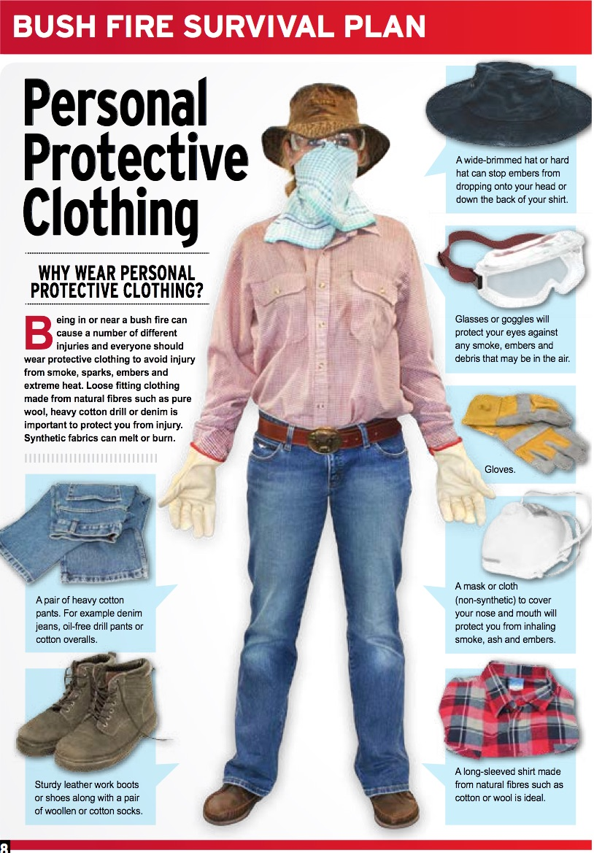](https://firesafemarin.org/wp-content/uploads/2015/10/bush-fire-clothing.jpg)